Internationally recognized  UET Graduates are Eligible To Work Globally As It Is Associated To Washington Accord Program Offered In Computer Science Recognized By Washington Accord  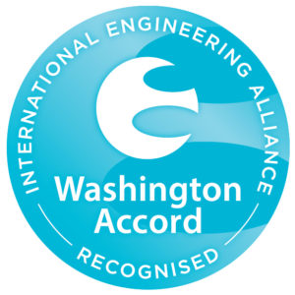 |  |  | aaa |  |  |  |  |  |  |  |  | 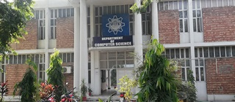  VISIT US ONLINE  lms.uet.edu.pk  cse.uet.edu.pk  uet.acm@gmail.com | 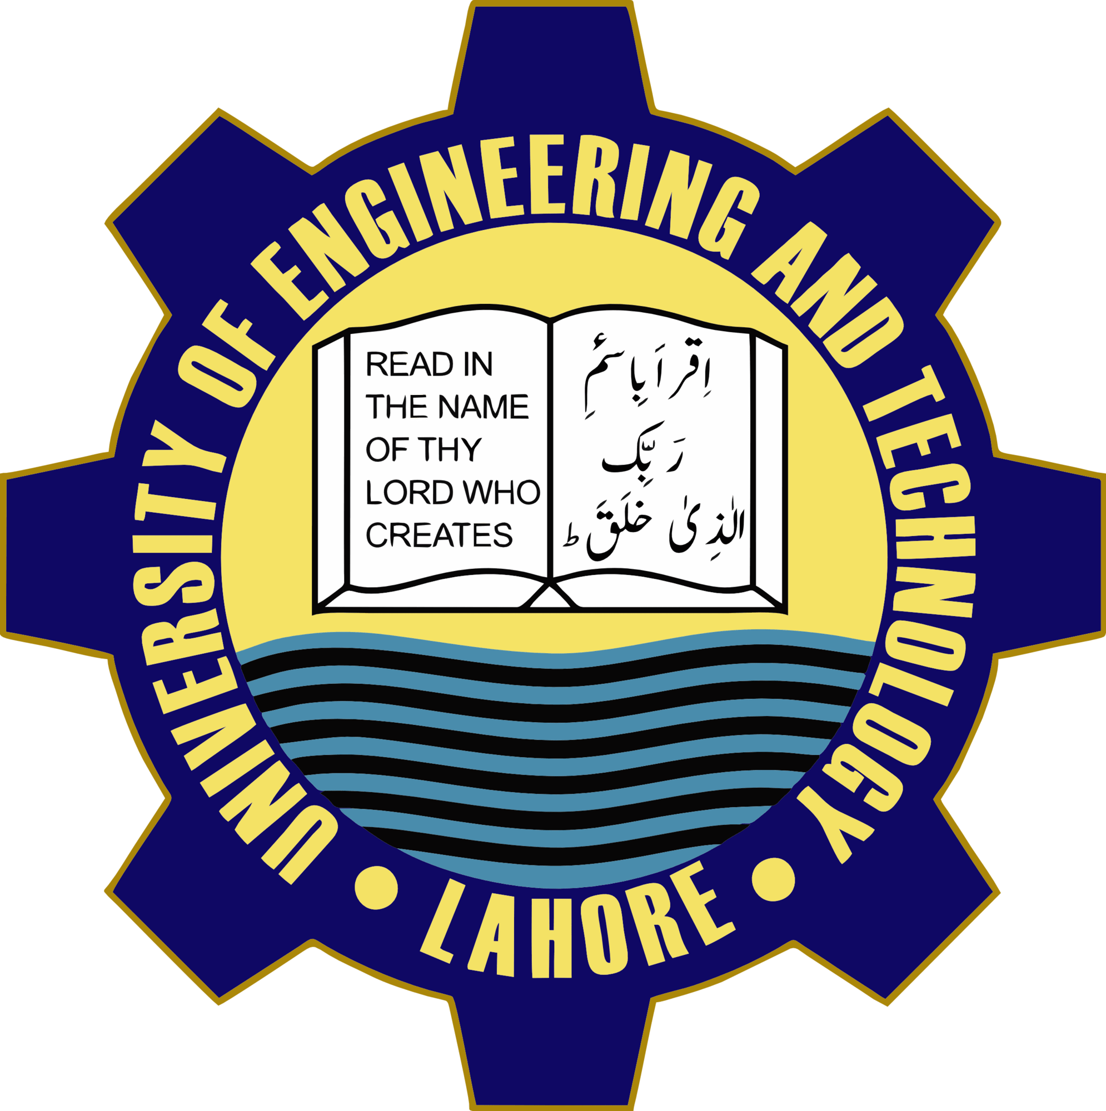  Department of Computer science and Engineering, UET Lahore  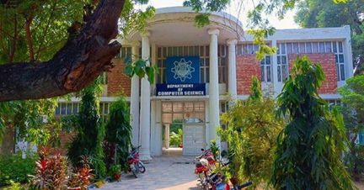

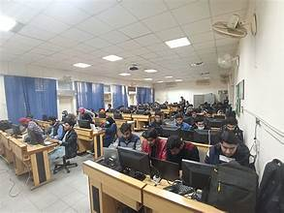  Courses Offered  - BSC Computer Engineering  - BSC Computer Sciences  - MSC Computer Science  - MSC Computer Engineering  Careers  Software Development  Network & Computer System Administrator’s  Computer Network & Architect | The Science of Today is THE Technology of Tomorrow  Edward Teller  Technical Society  UET ACM is one of the most celebrated scientific society which is actively participated in different events in collaboration with ICOSST (KICS)  - IEEE UET Society  - COMPUTER CLUB  - IET SOCITEY  COMPUTER FACILITIES  Computer cell is providing computer facilities with the advance internet services to the whole university. | Dean: prof. Dr. Suhail Aftab quarshi  Chairman: Prof. Dr. Muhammad Shahbaz  CONTACT US  UET Admission 042-99029216  Registrar 042-99029227  Deputy Registrar 042-9902909  Assistant Registrar 042-99029417

